**Forces Connect South West Veterans Outreach Service**

We will be at the Humphry Davy Statue,

Market Jew Street, Penzance, TR18 2LB

on 26th February 2020 from 1000-1500hrs hrs.

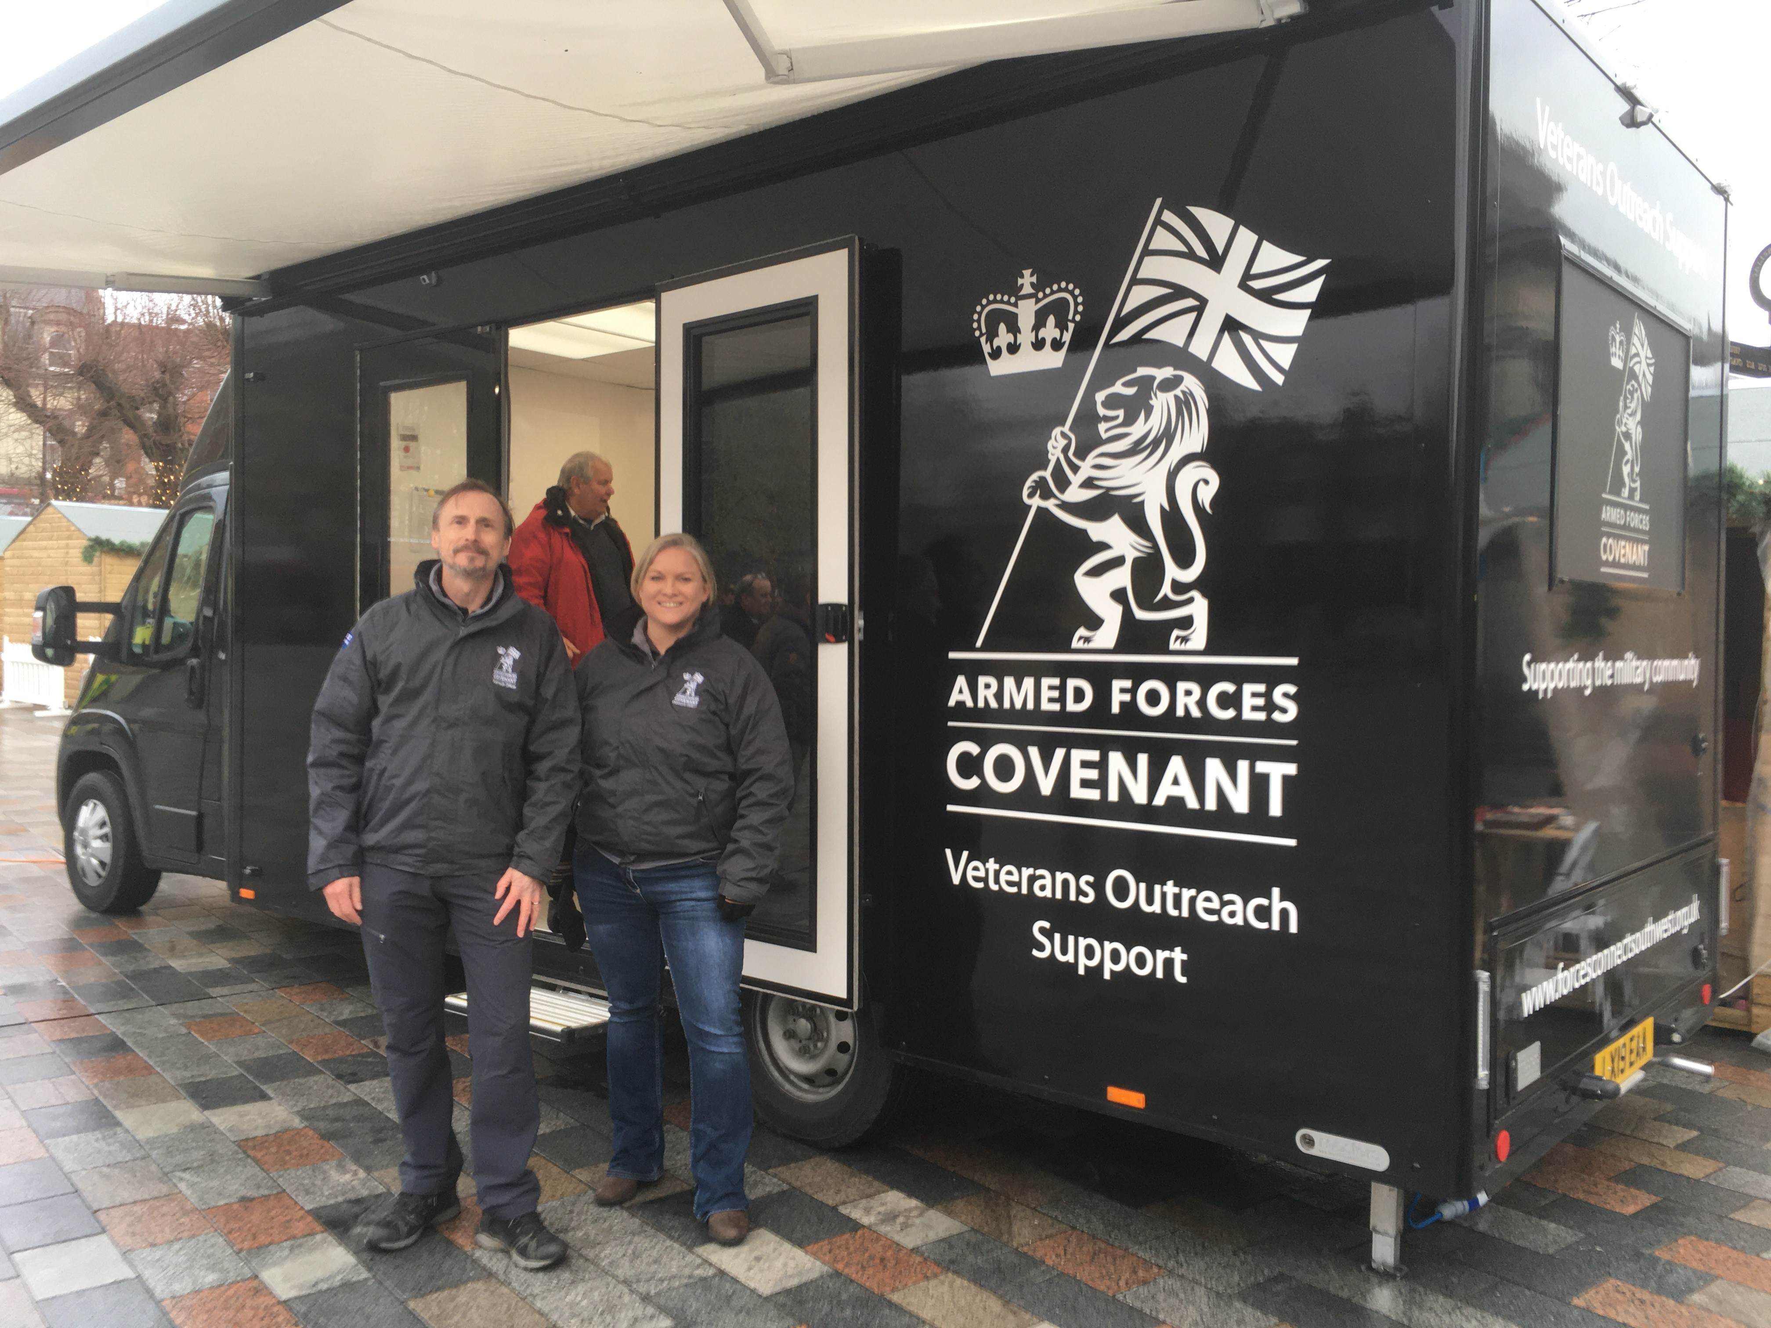 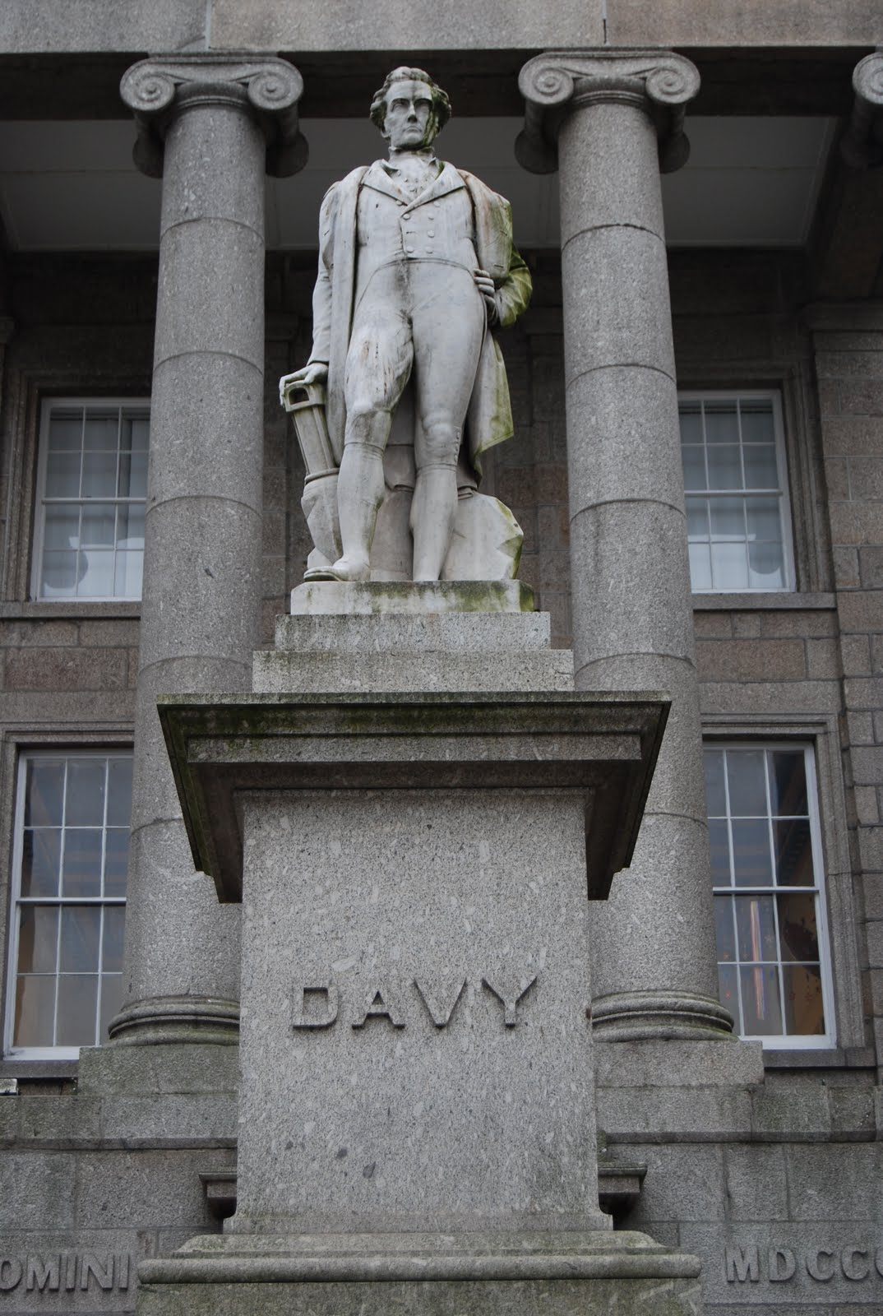

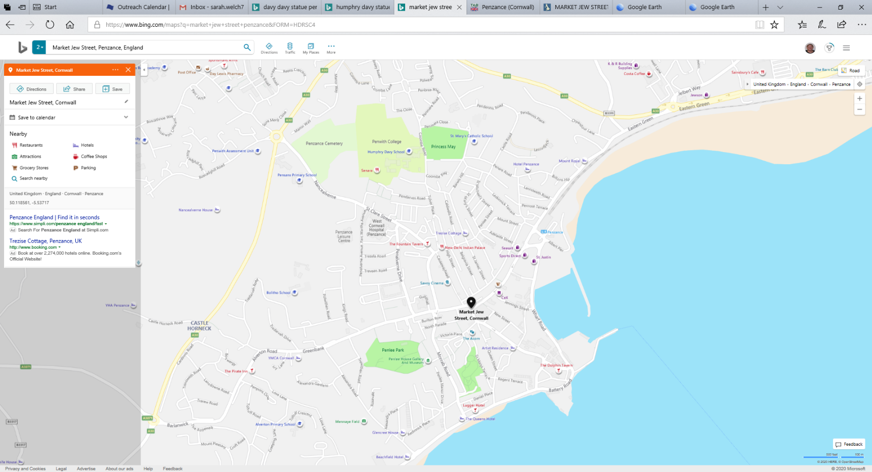

Co-op

Star Inn

Lloyds Bank

