Forces Connect South West Veterans Outreach Service

The Veterans Outreach Service will be joining 39 Signal Regiment as they exercise their Freedom of the City by way of a parade to coincide with the Royal Corps of Signals 100th anniversary.

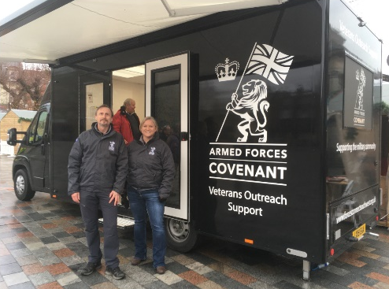
We will be a the Neptune Statue, Central Promenade, Bristol, BS1 4DA on Saturday 22nd February 2020 from 0900 – 1500 hrs.

